Project Report

Student and faculty rds

Member : Md. Nasim Ahmed
ID : 2232936042
Course : CSE215
Section : 09
Submission Date : 17/11/23

Student and faculty rds

Here a student needs to login with password. He/she can check the CGPA , courses with individual grades. Faculty can add new course and grades in a students profile , check past one’s .

*Register : Student and faculty needs to register first with all information asked and set a password
*Login : Student and faculty needs to login with id and password
* Grades : Student can check overall CGPA and courses with individual grades.
*Submit Grades : Faculty can submit grades for their subjects in a students profle and check past grades of the student
*Check info : Faculty can see any information of an individual student submitted by the student

1.Info : Info is the interface of the programme which contains the abstract methods void getNamee() and void getPasss() , which are implemented by the class “RegLOg”.

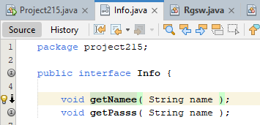

Implantation of the interface.
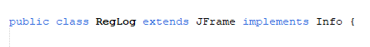
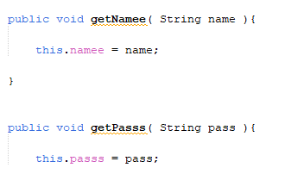

2.Rgsw : This class is the first class using “swing”, presents a screen in front of the user and gives the user to choose an option between “Faculty” and “Student”. After taking the input the “Rgsw” constructor passes the information class by class and reacts accordingly.
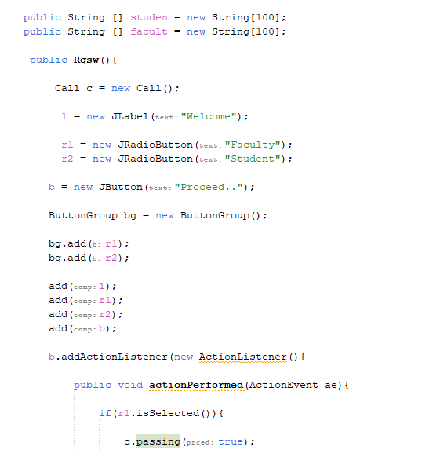
Swing screen of the class.
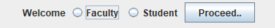
3.Call : A class that offers two options in front of the user weather to “register” as a new user or “login” being a registered user. Then the class calls the “register” or “login” method from the next class “RegLog” according to the response of the user.
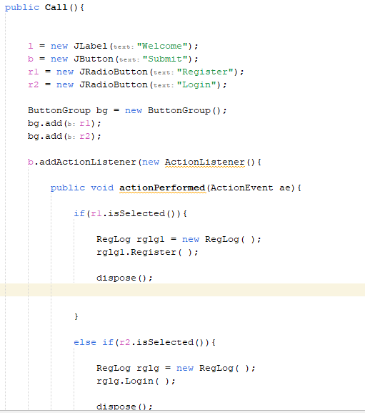
Call screen.
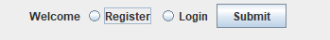
4.RegLog : Reglog is the class implementing the interface “Info”. This class handles the registration and login part of the programme and let’s the user go ahead.

Register : It is a method which executes the registration part. The method takes input from the user and saves them in files and let’s then go ahead to login.
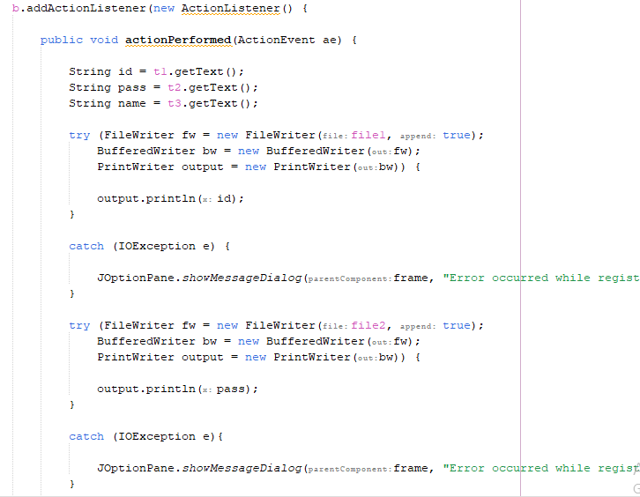
Register screen
Login : “Login” method is called either after registration or immediately by the call class if the user is registered already. This method takes input and matches them with the information saved earlier from the same user and if matches user can proceed. This method reacts as the user logged in as a faculty or student.
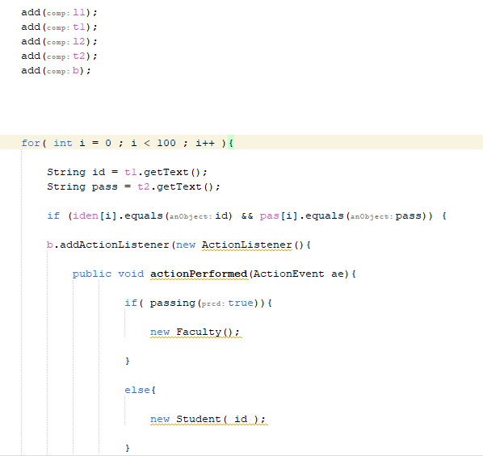

5.Faculty : Faculty class is called if the user is register’s and login’s as a faculty. This class gives the faculty three options of adding new course in the students profile , submitting the grade and checking the past grade of the student.
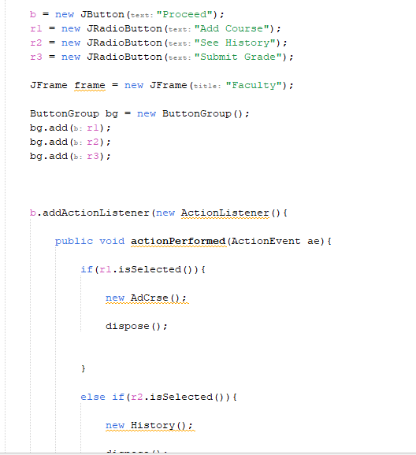
Three options for faculty to choose within.
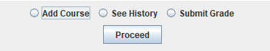
6. AdCrse : If the faculty chooses to add new courses to the students profile, faculty will get the screen shown from this class and he/she needs to provide the id of the student and course code . After that the course will be added to the profile of the perticular student and data will be saved in a file.
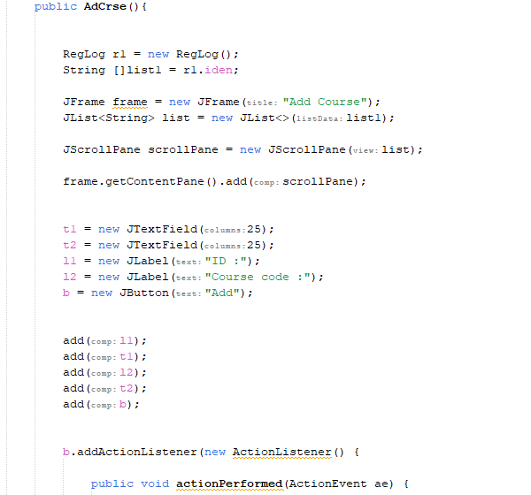

7. SubGrd : SubGrd allows the faculty to submit the grade of a perticular subject in a students profile by taking the id , course code and grade from the faculty.

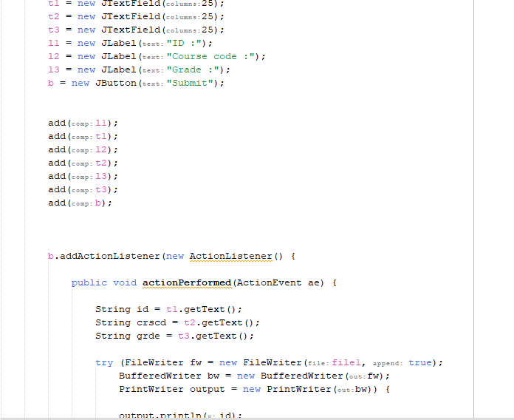

8. History : If the faculty wants to see the past grades of a student then he/she will choose the “See History” options which will lead him/her to this screen where faculty will have to provide the student profile id that he/she wants to visit.
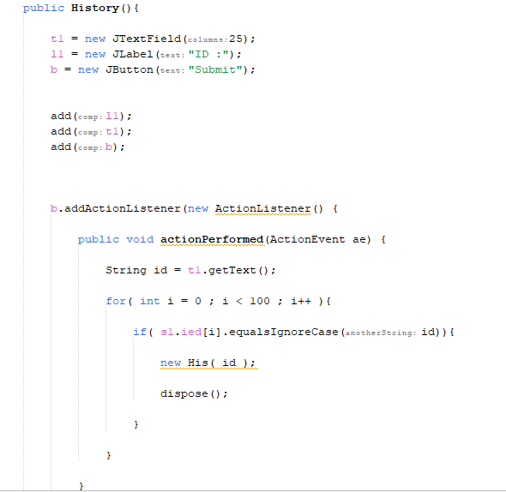

9. His : Presentation of the past grades of a student is done by the class. This class can be called by both faculty and student by checking the saved informations into different strings form files provided by a faculty.
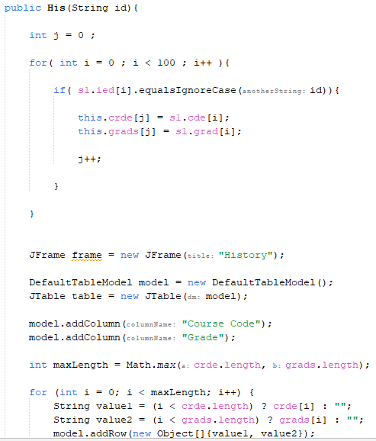
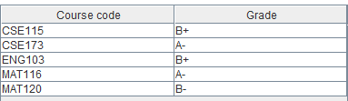
10. Student : Just like the “Faculty” class “Student” class also gives the student options. Two options are given to the student of checking past and ongoing courses or checking the past grades. Then the class calls next class accordingly.

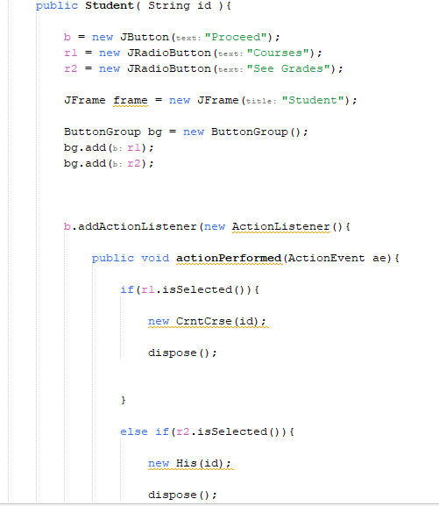

11.CrntCrse : A course that is called if the student wants to see the past and ongoing courses of him/her.
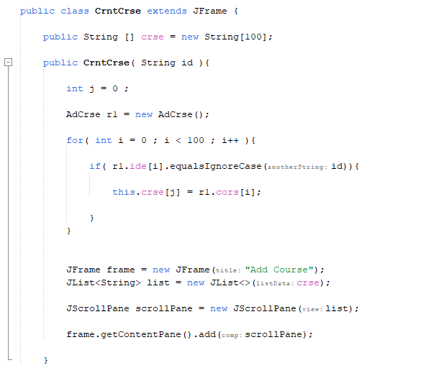
Presentation of the courses.
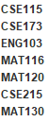
This programme has used a lot of features of java. The whole programme is build using swing to make the presentation better. The features that are used in the programme are…

1.Interface :

2.Class :
3.Method :
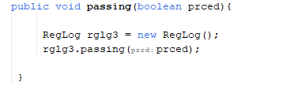
4.Object :

5.Polymorphism :

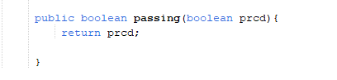
6.Inheritance :
7.Exception :
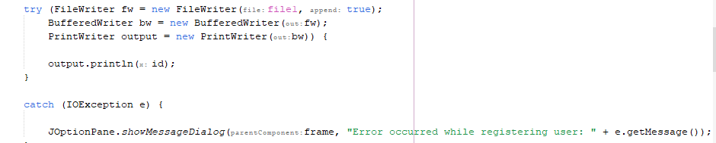

8.File :
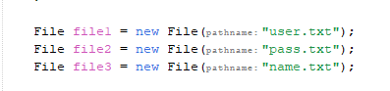

9.Array :
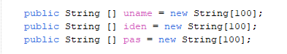

The whole project and report is done by Md. Nasim Ahmed. The course was really enjoyable and a lot learning topics were there. During the project the most difficult part was working with the files. A lot of new features can be added in the programme like parent rds system, advising( enrollment system), and etc. Thank you for teaching in such a way that helped me to learn.

Thank you

